Assignment - 4

|  |  |
| --- | --- |
| Assignment Date | 27 October 2022 |
| Student Roll Number | PNT2022TMID19751 |
| Maximum Marks | 2 Marks |

Question 1:

Pull an image from docker hub and run it in docker playground.

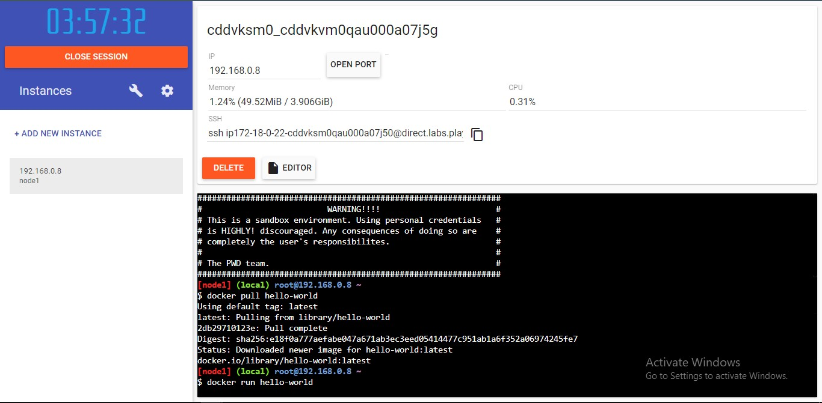

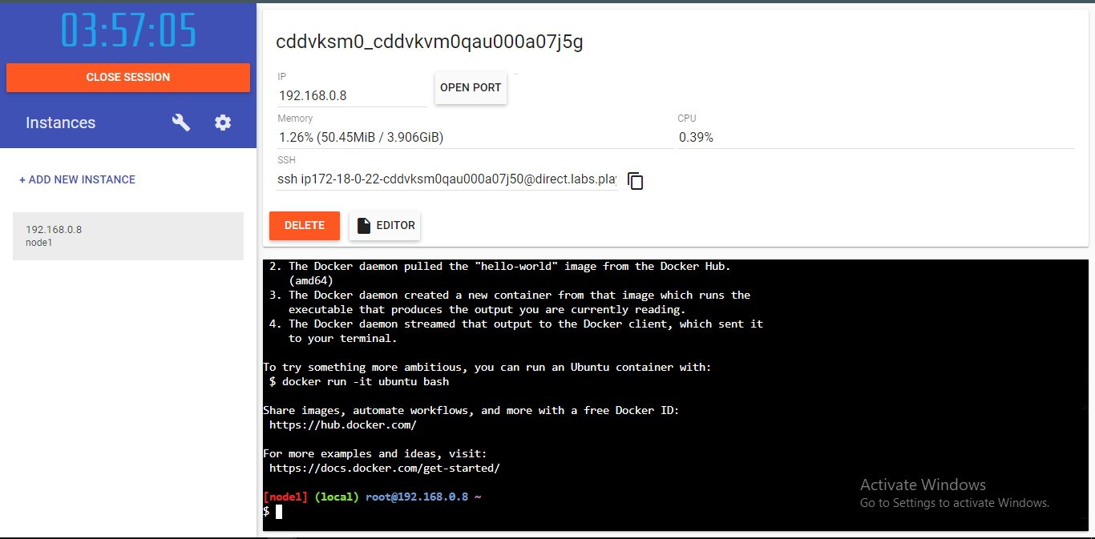

Question 2:

Create a docker ﬁle for the jobportal application and deploy it in Docker desktop application.

DOCKERFILE:

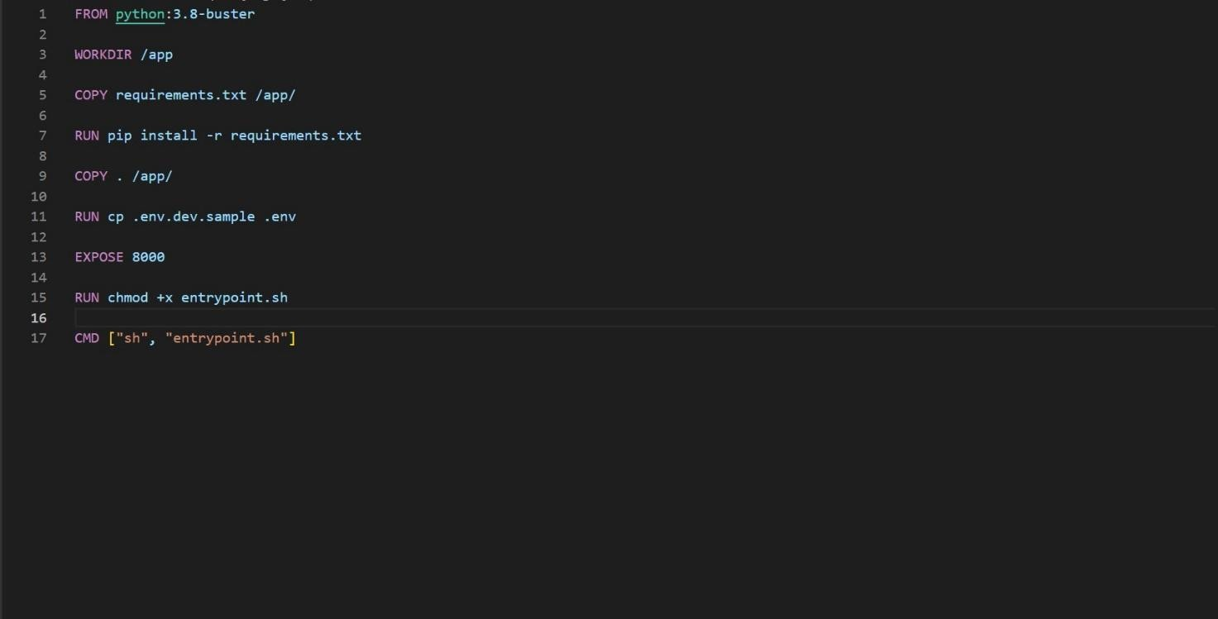

DEPLOYMENT OF JOBPORTAL APPLICATION:

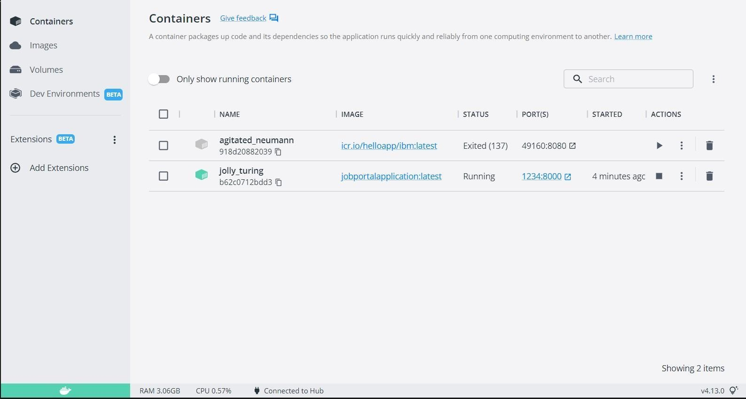

OUTPUT:

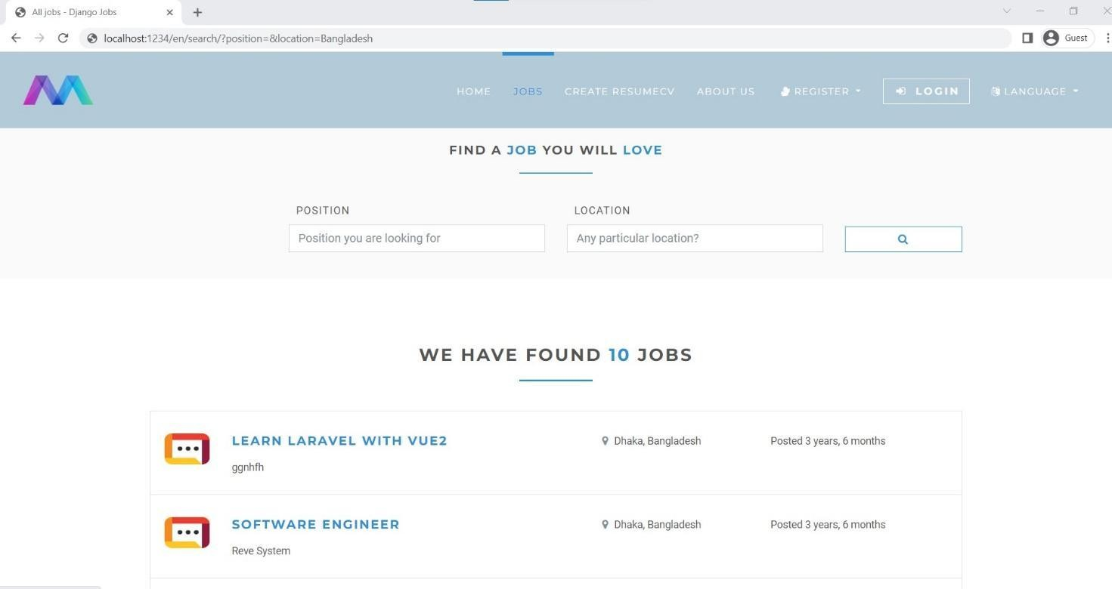

Question 3:

Create a IBM container registry and deploy helloworld app or jobportapp.

IBM CONTAINER REGISTRY DEPLOYMENT:

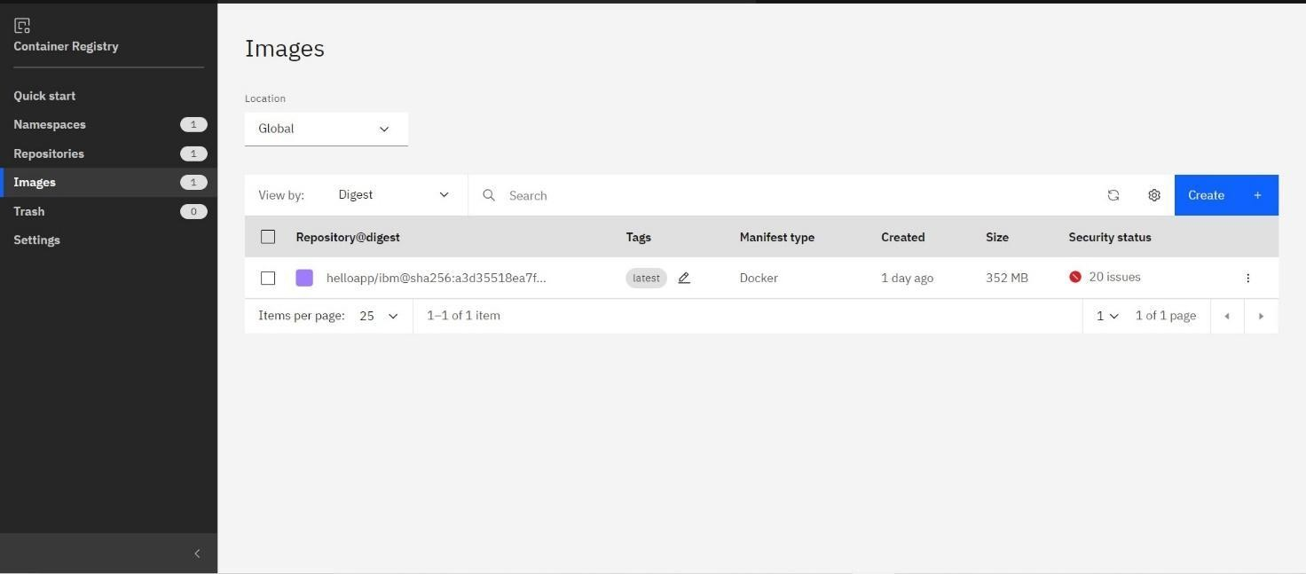

OUTPUT:



Question 4:

**Create a Kubernetes cluster in IBM cloud and deploy helloworld image or jobportal image and also expose the same app to run in nodeport.**

Creating kubernetes cluster in IBM cloud and exposing nodeport:

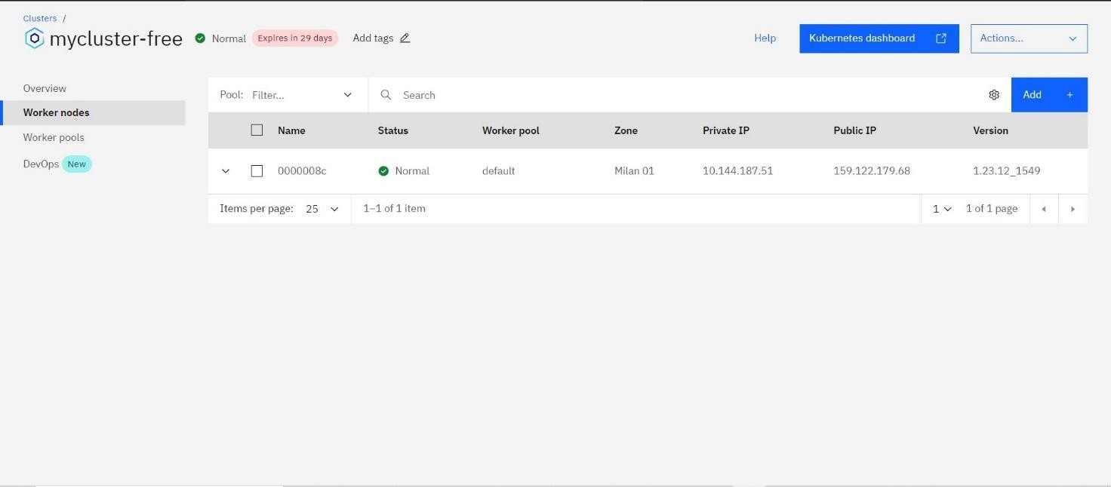

Output:

